Introduction to Convolutional Neural Networks

In the past chapters we have looked at fully connected networks and all the problems you encounter while training them. The network architecture we have used, one where each neuron in a layer is connected to all neurons in the previous and next layer, is not really good at many fundamental tasks like image recognition, speech recognition, time series prediction and many more. **Convolutional Neural Networks** (CNN) and **Recurrent Neural Networks** (RNN) are the most advanced architectures used today. In this chapter we will look at convolution and pooling, the basic building blocks of CNNs. We will also discuss a complete, although basic, implementation of CNNs in Keras. RNNs will be discussed, although briefly, in the next chapter.

# Kernels and filters

One of the main components of CNNs are filters, square matrices that have dimensions $n_{K}×n_{K}$, where usually $n_{K}$ is a small number, like $3$ or $5$. Sometimes filters are also called kernels. Let us define here four different filters and let us check later in the chapter their effect when used in convolution operations. For those examples, we will work with $3×3$ filters. For the moment just take the following definitions as a reference and we will see how to use them later in the chapter.

* The following kernel will allow the detection of horizontal edges $$I_{H}=\left(\begin{matrix}1 & 1 & 1 \\ 0 & 0 & 0 \\ -1 & -1 & -1\end{matrix}\right)$$
* The following kernel will allow the detection of vertical edges $$I_{V}=\left(\begin{matrix}1 & 0 & -1 \\ 1 & 0 & -1 \\ 1 & 0 & -1\end{matrix}\right)$$
* The following kernel will allow the detection of edges when luminosity changes drastically $$I_{L}=\left(\begin{matrix}-1 & -1 & -1 \\ -1 & 8 & -1 \\ -1 & -1 & -1\end{matrix}\right)$$
* The following kernel will blur edges in an image $$I_{B}=-\frac{1}{9}\left(\begin{matrix}1 & 1 & 1 \\ 1 & 1 & 1 \\ 1 & 1 & 1\end{matrix}\right)$$

In the next sections we will apply convolution to a test image with the filters and you will see what their effect is.

## Convolution

The first step to understand CNNs is to understand convolution. The easiest way is to see it in action in a few simple cases. First, in the context of neural networks, convolution is done between tensors. The operation gets two tensors as input and produce a tensor as output. The operation is usually indicated with the operator $*$. Let us see how it works. Let us get two tensors, both with dimensions $3×3$. The convolution operation is done applying the following formula

$$\left(\begin{matrix}a_{1} & a_{2} & a_{3} \\ a_{4} & a_{5} & a_{6} \\ a_{7} & a_{8} & a_{9}\end{matrix}\right)*\left(\begin{matrix}k_{1} & k_{2} & k_{3} \\ k_{4} & k_{5} & k_{6} \\ k_{7} & k_{8} & k_{9}\end{matrix}\right)=\sum_{i=1}^{9}{a_{i}k_{i}}$$

In this case the result is simply the sum of each element $a_{i}$ multiplied by the respective element $k_{i}$. In a more typical matrix formalism this formula could be written with a double sum as

$$\left(\begin{matrix}a_{11} & a_{12} & a_{13} \\ a_{21} & a_{22} & a_{23} \\ a_{31} & a_{32} & a_{33}\end{matrix}\right)*\left(\begin{matrix}k_{11} & k_{12} & k_{13} \\ k_{21} & k_{22} & k_{23} \\ k_{31} & k_{32} & k_{33}\end{matrix}\right)=\sum_{i=1}^{3}{\sum_{j=1}^{3}{a_{ij}k_{ij}}}$$

but the first version has the advantage of making the fundamental idea very clear: each element from one tensor is multiplied by the correspondent element (the element in the same position) of the second tensor and then all the values are summed to get the result.

In the previous section we have talked about kernels, and the reason is that convolution is usually done between a tensor, that we may indicate here with $A$, and a kernel. Typically, kernels are small, $3×3$ or $5×5$, while the input tensors $A$ are normally bigger. In image recognition for example, the input tensors $A$ are the images that may have dimensions as high as $1024×1024×3$, where $1024×1024$ is the resolution and the last dimension ($3$) is the number of the color channels, the RGB values. In advanced applications the images may even have higher resolution. How to apply convolution when we have matrices with different dimensions? To understand it, let us consider a matrix $A$ that is $4×4$

$$A=\left(\begin{matrix}a_{1} & a_{2} & a_{3} & a_{4} \\ a_{5} & a_{6} & a_{7} & a_{8} \\ a_{9} & a_{10} & a_{11} & a_{12} \\ a_{13} & a_{14} & a_{15} & a_{16}\end{matrix}\right)$$

and let us see how to do convolution with a Kernel $K$ that we will take for this example to be $3×3$

$$K=\left(\begin{matrix}k_{1} & k_{2} & k_{3} \\ k_{4} & k_{5} & k_{6} \\ k_{7} & k_{8} & k_{9}\end{matrix}\right)$$

The idea is to start on the top left corner of the matrix $A$ and select a $3×3$ region. In the example that would be

$$A_{1}=\left(\begin{matrix}a_{1} & a_{2} & a_{3} \\ a_{5} & a_{6} & a_{7} \\ a_{9} & a_{10} & a_{11}\end{matrix}\right)$$

or the elements marked in bold below

$$A=\left(\begin{matrix}a_{1} & a_{2} & a_{3} & a_{4} \\ a_{5} & a_{6} & a_{7} & a_{8} \\ a_{9} & a_{10} & a_{11} & a_{12} \\ a_{13} & a_{14} & a_{15} & a_{16}\end{matrix}\right)$$

Then we perform the convolution, as explained at the beginning between this smaller matrix $A_{1}$ and $K$ getting (we will indicate the result with $B_{1})$

$$B_{1}=A_{1}*K=a_{1}k_{1}+a_{2}k_{2}+a_{3}k_{3}+k_{4}a_{5}+k_{5}a_{5}+k_{6}a_{7}+k_{7}a_{9}+k_{8}a_{10}+k_{9}a_{11}$$

Then we need to shift the selected $3×3$ region in matrix $A$ of one column to the right and select the elements marked in bold below

$$A=\left(\begin{matrix}a_{1} & a_{2} & a_{3} & a_{4} \\ a_{5} & a_{6} & a_{7} & a_{8} \\ a_{9} & a_{10} & a_{11} & a_{12} \\ a_{13} & a_{14} & a_{15} & a_{16}\end{matrix}\right)$$

that will give us the second sub-matrix $A_{2}$

$$A_{2}=\left(\begin{matrix}a_{2} & a_{3} & a_{4} \\ a_{6} & a_{7} & a_{8} \\ a_{10} & a_{11} & a_{12}\end{matrix}\right)$$

and we perform again the convolution between this smaller matrix $A_{2}$ and $K$

$$B_{2}=A_{2}*K=a_{2}k_{1}+a_{3}k_{2}+a_{4}k_{3}+a_{6}k_{4}+a_{7}k_{5}+a_{8}k_{6}+a_{10}k_{7}+a_{11}k_{8}+a_{12}k_{9}$$

Now we cannot shift our $3×3$ region anymore to the right, since we have reached the end of the matrix $A$, so what we do is that we shift it one row down and start again from the left side. The next selected region would be

$$A_{3}=\left(\begin{matrix}a_{5} & a_{6} & a_{7} \\ a_{9} & a_{10} & a_{11} \\ a_{13} & a_{14} & a_{15}\end{matrix}\right)$$

Again, we perform convolution of $A_{3}$ with $K$

$$B_{3}=A_{3}*K=a_{5}k_{1}+a_{6}k_{2}+a_{7}k_{3}+a_{9}k_{4}+a_{10}k_{5}+a_{11}k_{6}+a_{13}k_{7}+a_{14}k_{8}+a_{15}k_{9}$$

As you have guessed at this point, the last step is to shift our $3×3$ selected region to the right of one column and perform again convolution. Our selected region will now be

$$A_{4}=\left(\begin{matrix}a_{6} & a_{7} & a_{8} \\ a_{10} & a_{11} & a_{12} \\ a_{14} & a_{15} & a_{16}\end{matrix}\right)$$

and the convolution will give the result

$$B_{4}=A_{4}*K=a_{6}k_{1}+a_{7}k_{2}+a_{8}k_{3}+a_{10}k_{4}+a_{11}k_{5}+a_{12}k_{6}+a_{14}k_{7}+a_{15}k_{8}+a_{16}k_{9}$$

Now we cannot shift our $3×3$ region anymore, neither right nor down. We have calculated $4$ values: $B_{1}$, $B_{2}$, $B_{3}$ and $B_{4}$. Those elements will form the resulting tensor of the convolution operation giving us the tensor $B$

$$B=\left(\begin{matrix}B_{1} & B_{2} \\ B_{3} & B_{4}\end{matrix}\right)$$

The same process can be applied when the tensor $A$ is bigger. You will simply get a bigger resulting $B$ tensor, but the algorithm to get the elements $B_{i}$ is the same. Before moving on, there is still a small detail that we need to discuss, and that is the concept of **stride**. In the process above we have moved our $3×3$ region always one column to the right and one row down. The number of rows and columns, in this example 1, is called stride and is often indicated with $s$. Stride $s=2$ means simply that we would shift our $3×3$ region two columns to the right and two rows down. Something else that we need to discuss is the size of the selected region in the input matrix $A$. The dimensions of the selected region that we shifted around in the process, must be the same as of the kernel used. If you use a $5×5$ kernel, then you will need to select a $5×5$ region in $A$. In general, given a $n_{K}×n_{K}$ kernel you will select a $n_{K}×n_{K}$ region in $A$.

In a more formal definition, convolution with stride $s$ in the neural network context, is a process that takes a tensor $A$ of dimensions $n_{A}×n_{A}$ and a kernel $K$ of dimensions $n_{K}×n_{K}$ and gives as output a matrix $B$ of dimensions $n_{B}×n_{B}$ with

$$n_{B}=\left\lfloor \frac{n_{A}-n_{K}}{s}+1\right\rfloor$$

Where we have indicated with $\left\lfloor x\right\rfloor$ the integer part of $x$ (in the programming world, this is often called the floor of $x$). A proof of this formula would take too long to discuss but is easy to see why it is true (try to derive it). To make things a bit easier we will suppose that $n_{K}$ is odd. You will see soon why this is important (although not fundamental). Let us start explaining formally the case with a stride $s=1$. The algorithm generates a new tensor $B$ from an input tensor $A$ and a kernel $K$ according to the formula

$$B_{ij}={\left(A*K\right)}_{ij}=\sum_{f=0}^{n_{K}-1}{ \sum_{h=0}^{n_{K}-1}{A_{i+f, j+h}}}K_{i+f, j+h}$$

The formula is cryptic and is very difficult to understand. Let us check some more examples to grasp the meaning better. In Figure 15-1 you can see a visual explanation of how convolution works. Suppose you have a $3×3$ filter. Then in the Figure you can see that the top left 9 elements of the matrix $A$, marked by a square drawn with a black continuous line, are the one used to generate the first element of the matrix $B_{1}$ according to the formula above. The elements marked by the square drawn with a dotted line are the one used to generate the second element $B_{2}$ and so on. To reiterate what we discuss in the example at the beginning, the basic idea is that each element of the $3×3$ square from matrix $A$ is multiplied by the correspondent element of the Kernel $K$ and all the numbers are summed. The sum is then the element of the new matrix $B$. After having calculated the value for $B_{1}$ you shift the region you are considering in the original matrix of one column to the right (the square indicated in Figure 7-1 with a dotted line) and repeat the operation. You continue to shift your region to the right until you reach the border and then you move one element down and start again from the left and you continue in this fashion until the lower right angle of the matrix. The same kernel is used for all the regions in the original matrix.

Figure 7-1. A visual explanation of convolution.

Given the kernel $I_{H}$ for example you can see in Figure 7-2 which element of $A$ gets multiplied by which element in $I_{H}$ and the result for the element $B_{1}$, that is nothing else as the sum of all the multiplications

Figure 7-2. A visualization of convolution with the kernel $I_{H}$.

In Figure 7-3 you can see an indicative example of convolution with stride $s=2$.

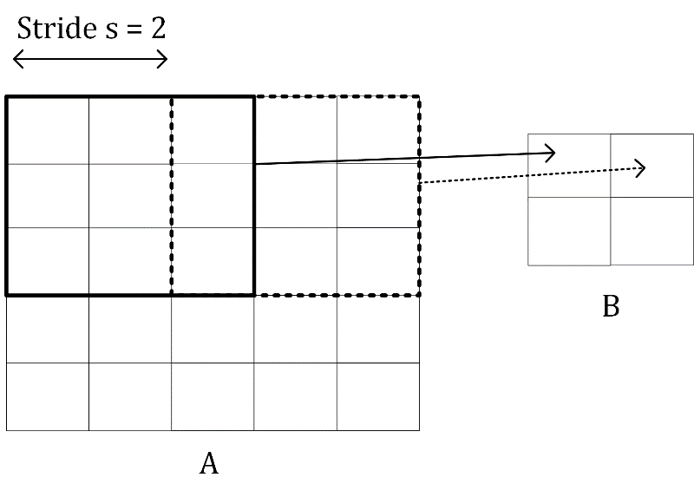

Figure 7-3. A visual explanation of convolution with stride $s=2$.

The reason why the dimension of the output matrix takes only the floor (the integer part) of $\frac{n_{A}-n_{K}}{s}+1$ can be seen intuitively in Figure 7-4. If $s>1$, what can happen, depending on the dimensions of $A$, is that at a certain point you cannot shift your window on matrix $A$ (the black square you can see in Figure 7-3 for example) anymore, and you cannot cover all the matrix $A$ completely. In Figure 7-4 you can see how you would need an additional column on the right of matrix $A$ (marked by many X) to be able to perform the convolution operation. In Figure 7-4 we have chosen $s=3$, and since we have $n_{A}=5$ and $n_{K}=3$, $B$ will be a scalar as a result

Figure 7-4. A visual explanation why the floor function is needed when evaluating the resulting matrix $B$ dimensions.

You can easily see from Figure 7-4 how with a $3×3$ region you can only cover the top left region of $A$, since with stride $s=3$ you would end up outside $A$ and therefore can consider one region only for the convolution operation, therefore ending up with a scalar for the resulting tensor $B$.

Let us now make a few additional examples to make this formula even clearer. Let us start with a small matrix $3×3$

$$A=\left(\begin{matrix}1 & 2 & 3 \\ 4 & 5 & 6 \\ 7 & 8 & 9\end{matrix}\right)$$

and let us consider the kernel

$$K=\left(\begin{matrix}k_{1} & k_{2} & k_{3} \\ k_{4} & k_{5} & k_{6} \\ k_{7} & k_{8} & k_{9}\end{matrix}\right)$$

and stride $s=1$. The convolution will be given by

$$B=A*K=1⋅k_{1}+2⋅k_{2}+3⋅k_{3}+4⋅k_{4}+5⋅k_{5}+6⋅k_{6}+7⋅k_{7}+8⋅k_{8}+9⋅k_{9}$$

and the result $B$ will be a scalar, since $n_{A}=3$, $n_{K}=3$ therefore

$$n_{B}=\left\lfloor \frac{n_{A}-n_{K}}{s}+1\right\rfloor =\left\lfloor \frac{3-3}{1}+1\right\rfloor =1$$

If now you consider a matrix $A$ with dimensions $4×4$, or $n_{A}=4$, $n_{K}=3$ and $s=1$ you will get as output a matrix $B$ with dimensions $2×2$, since

$$n_{B}=\left\lfloor \frac{n_{A}-n_{K}}{s}+1\right\rfloor =\left\lfloor \frac{4-3}{1}+1\right\rfloor =2$$

For example, you can verify that given

$$A=\left(\begin{matrix}1 & 2 & 3 & 4 \\ 5 & 6 & 7 & 8 \\ 9 & 10 & 11 & 12 \\ 13 & 14 & 15 & 16\end{matrix}\right)$$

and

$$K=\left(\begin{matrix}1 & 2 & 3 \\ 4 & 5 & 6 \\ 7 & 8 & 9\end{matrix}\right)$$

we have with stride $s=1$

$$B=A*K=\left(\begin{matrix}348 & 393 \\ 528 & 573\end{matrix}\right)$$

Let us verify one of the elements: $B_{11}$ with the formula we saw before. We have

$$\begin{matrix}B_{11}=\sum_{f=0}^{2}{ \sum_{h=0}^{2}{A_{1+f,1+h}}}K_{1+f, 1+h}=\sum_{f=0}^{2}{{(A}_{1+f, 1}K_{1+f,1}+A_{1+f, 2}K_{1+f,2}+A_{1+f, 3}K_{1+f,3})=} \\ { (A}_{1, 1}K_{1,1}+A_{1, 2}K_{1,2}+A_{1, 3}K_{1,3})+{(A}_{2, 1}K_{2,1}+A_{2, 2}K_{2,2}+A_{2, 3}K_{2,3})+ \\ { (A}_{3, 1}K_{3,1}+A_{3, 2}K_{3,2}+A_{3, 3}K_{3,3})=\left(1⋅1+2⋅2+3⋅3\right)+\left(5⋅4+6⋅5+7⋅6\right)+ \\ \left(9⋅7+10⋅8+11⋅9\right)=14+92+242=348\end{matrix}$$

Note that the formula for the convolution works only for stride $s=1$, but can be easily generalized for other values of $s$.

This calculation is very easy to implement in Python. The following function can evaluate the convolution of two matrices easily enough for $s=1$ (you can do it in Python with already existing functions, but it is instructive to see how to do it from scratch)

import numpy as np

def conv_2d(A, kernel):

output = np.zeros([A.shape[0]-(kernel.shape[0]-1), A.shape[1]-(kernel.shape[0]-1)])

for row in range(1, A.shape[0]-1):

for column in range(1, A.shape[1]-1):

output[row-1, column-1] = np.tensordot(A[row-1:row+2, column-1:column+2], kernel)

return output

note that the input matrix A does not even need to a square one, but it is assumed that the kernel is and that its dimension $n_{K}$ is odd. The previous example can be evaluated with the following code

A = np.array([[1,2,3,4],[5,6,7,8],[9,10,11,12],[13,14,15,16]])

K = np.array([[1,2,3],[4,5,6],[7,8,9]])

print(conv_2d(A,K))

this gives the result

[[ 348. 393.]

[ 528. 573.]]

### Examples of convolution

Now let us try to apply the kernels we have defined at the beginning to a test image and let us see the results. As a test image let us create a chessboard of dimensions $160×160$ pixels with the code

chessboard = np.zeros([8*20, 8*20])

for row in range(0, 8):

for column in range (0, 8):

if ((column+8*row) % 2 == 1) and (row % 2 == 0):

chessboard[row*20:row*20+20, column*20:column*20+20] = 1

elif ((column+8*row) % 2 == 0) and (row % 2 == 1):

chessboard[row*20:row*20+20, column*20:column*20+20] = 1

In Figure 7-5 you can see how the chessboard looks like.

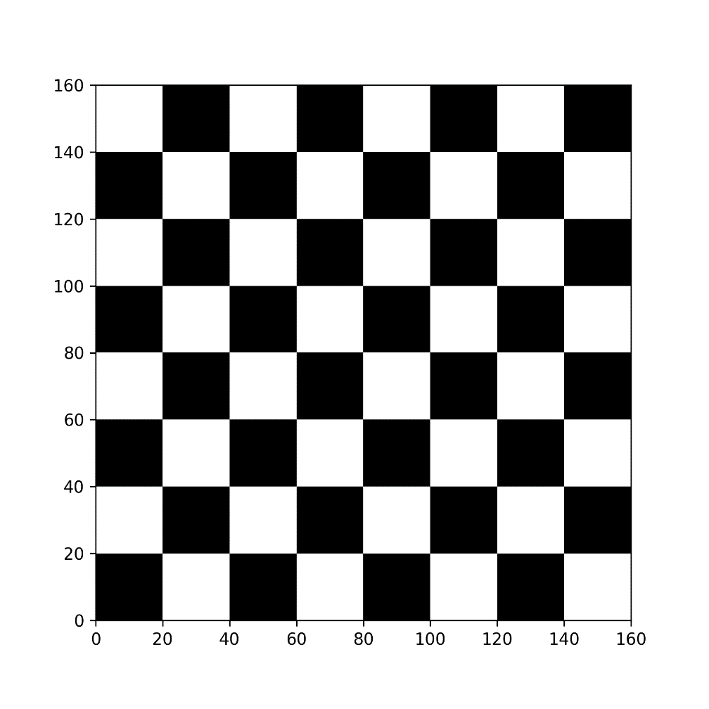

Figure 7-5. The chessboard image generated with code.

Now let us try to apply convolution to this image with the different kernels with stride $s=1$.

Using the kernel $I_{H}$ will detect the horizontal edges. This can be applied with the code

edgeh = np.matrix('1 1 1; 0 0 0; -1 -1 -1')

outputh = conv_2d (chessboard, edgeh)

In Figure 7-6 you can see how the output looks like.

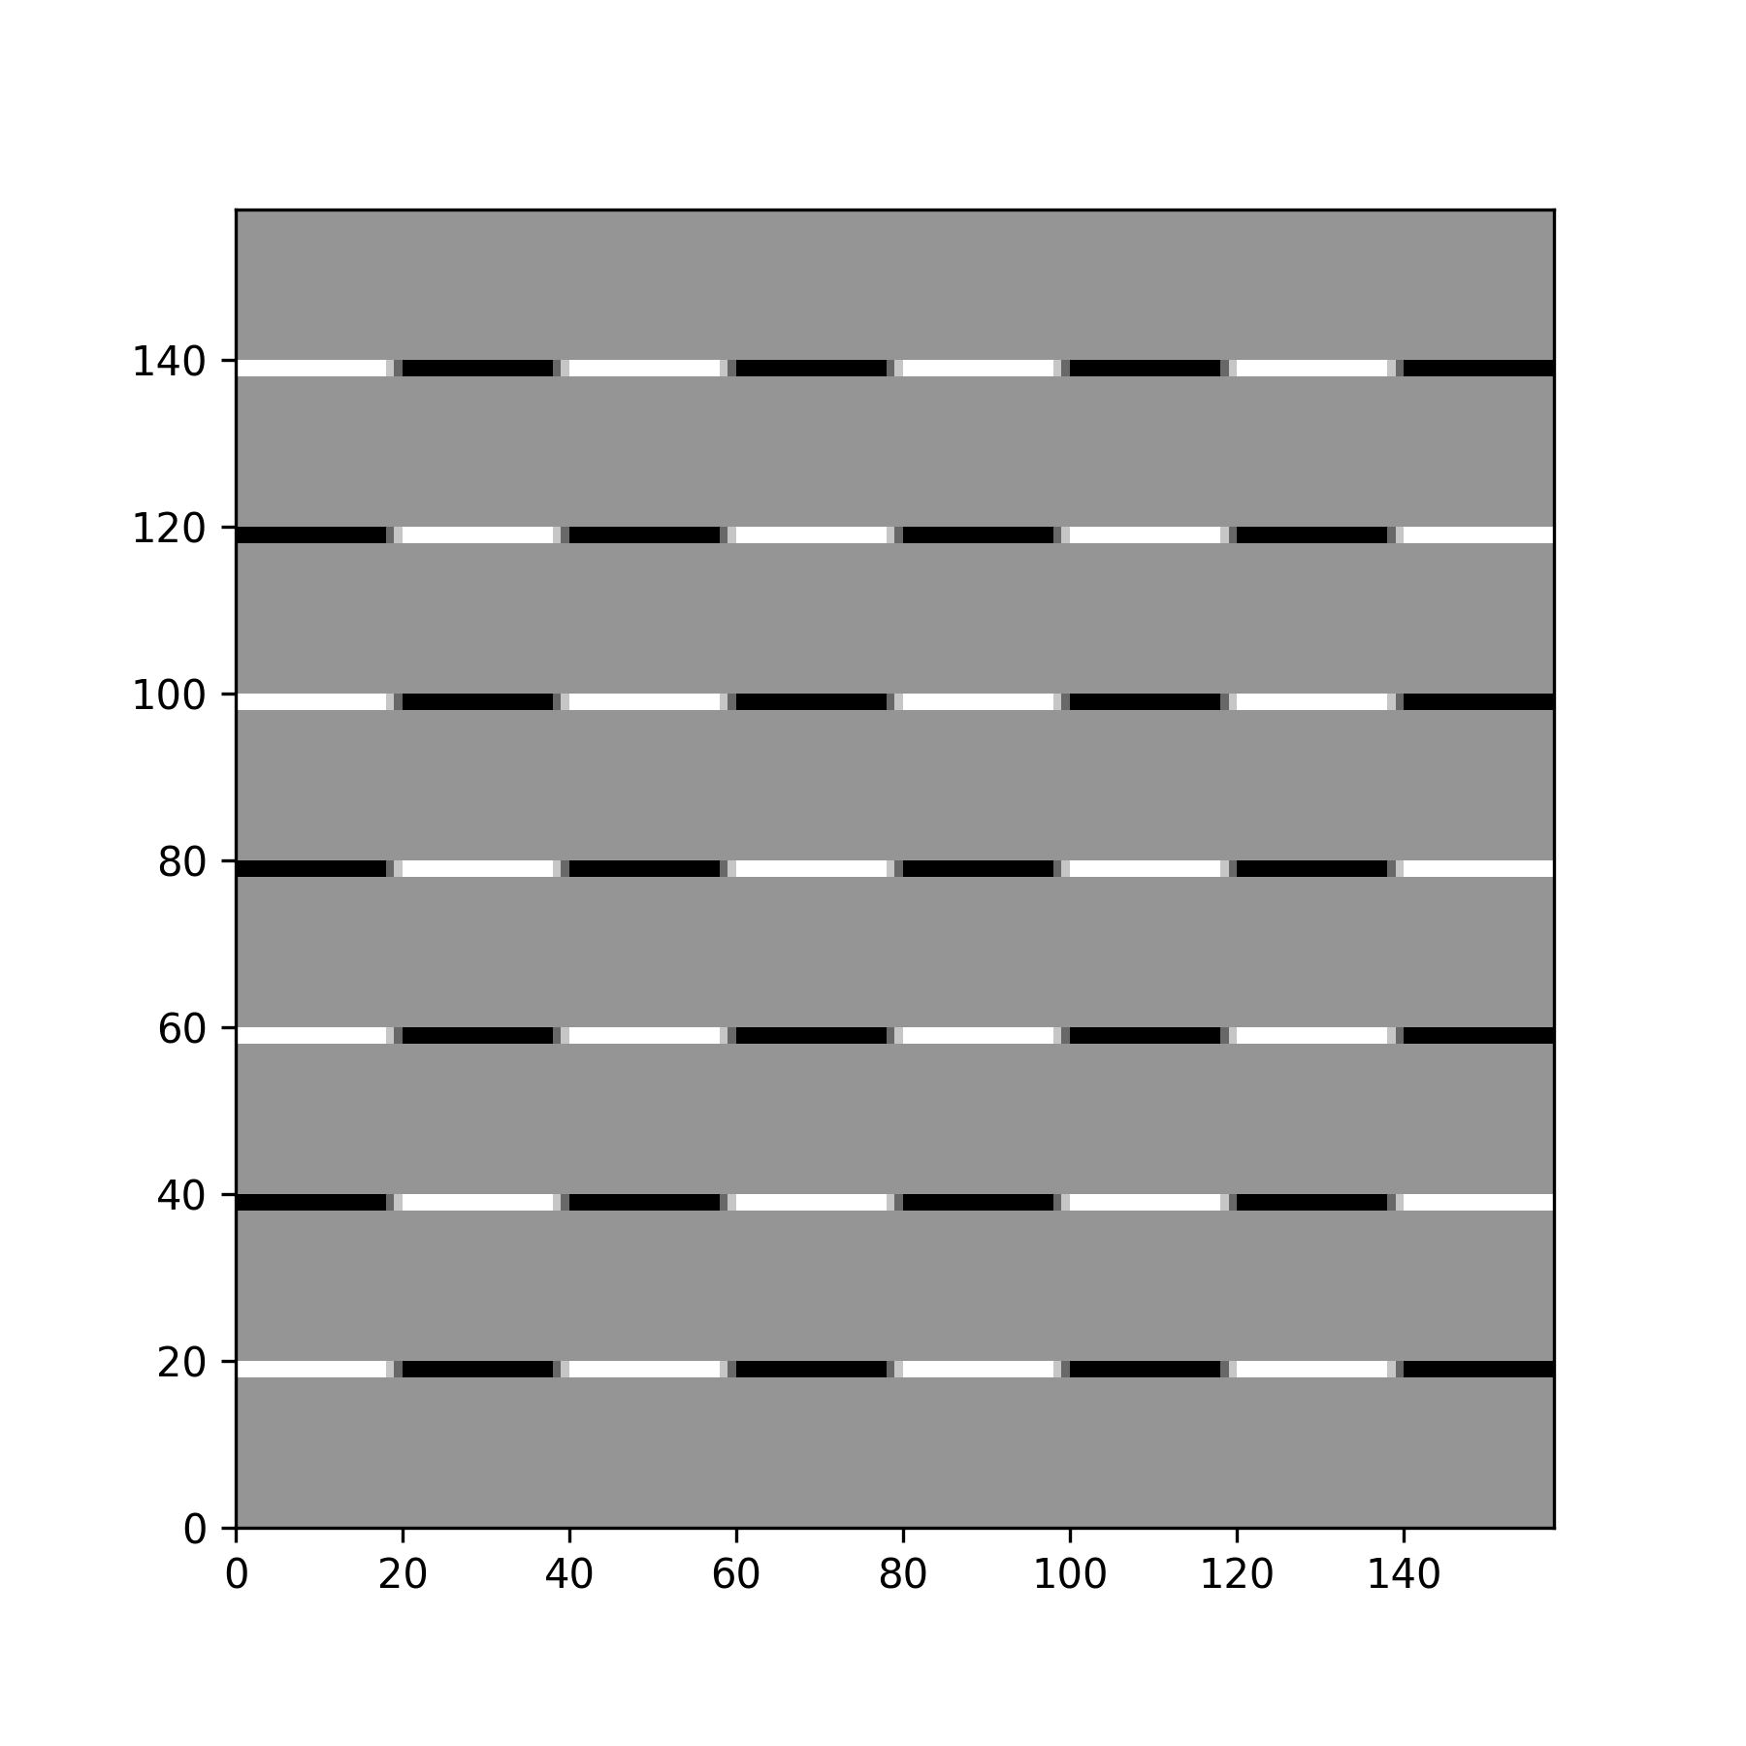

Figure 7-6. The result of performing a convolution between the kernel $I_{H}$ and the chessboard image.

Now you can understand why this kernel detects horizontal edges. Additionally, this kernel detects if you go from light to dark or vice versa. Note this image is only $158×158$ pixels as expected since

$$n_{B}=\left\lfloor \frac{n_{A}-n_{K}}{s}+1\right\rfloor =\left\lfloor \frac{160-3}{1}+1\right\rfloor =\left\lfloor \frac{157}{1}+1\right\rfloor =\left\lfloor 158\right\rfloor =158$$

Now let us apply $I_{V}$ with the code

edgev = np.matrix('1 0 -1; 1 0 -1; 1 0 -1')

outputv = conv_2d (chessboard, edgev)

This gives the result in Figure 7-7.

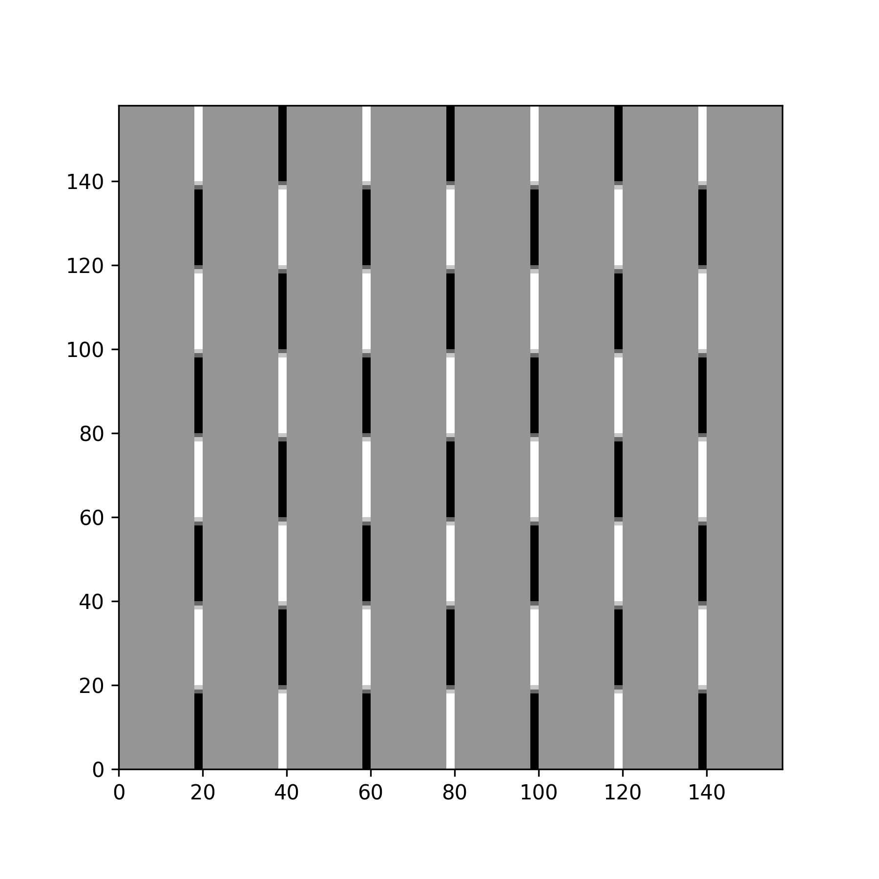

Figure 7-7. The result of performing a convolution between the kernel $I_{V}$ and the chessboard image.

Now we can use the kernel $I_{L}$

edgel = np.matrix ('-1 -1 -1; -1 8 -1; -1 -1 -1')  
outputl = conv_2d (chessboard, edgel)

This gives the result in Figure 7-8.

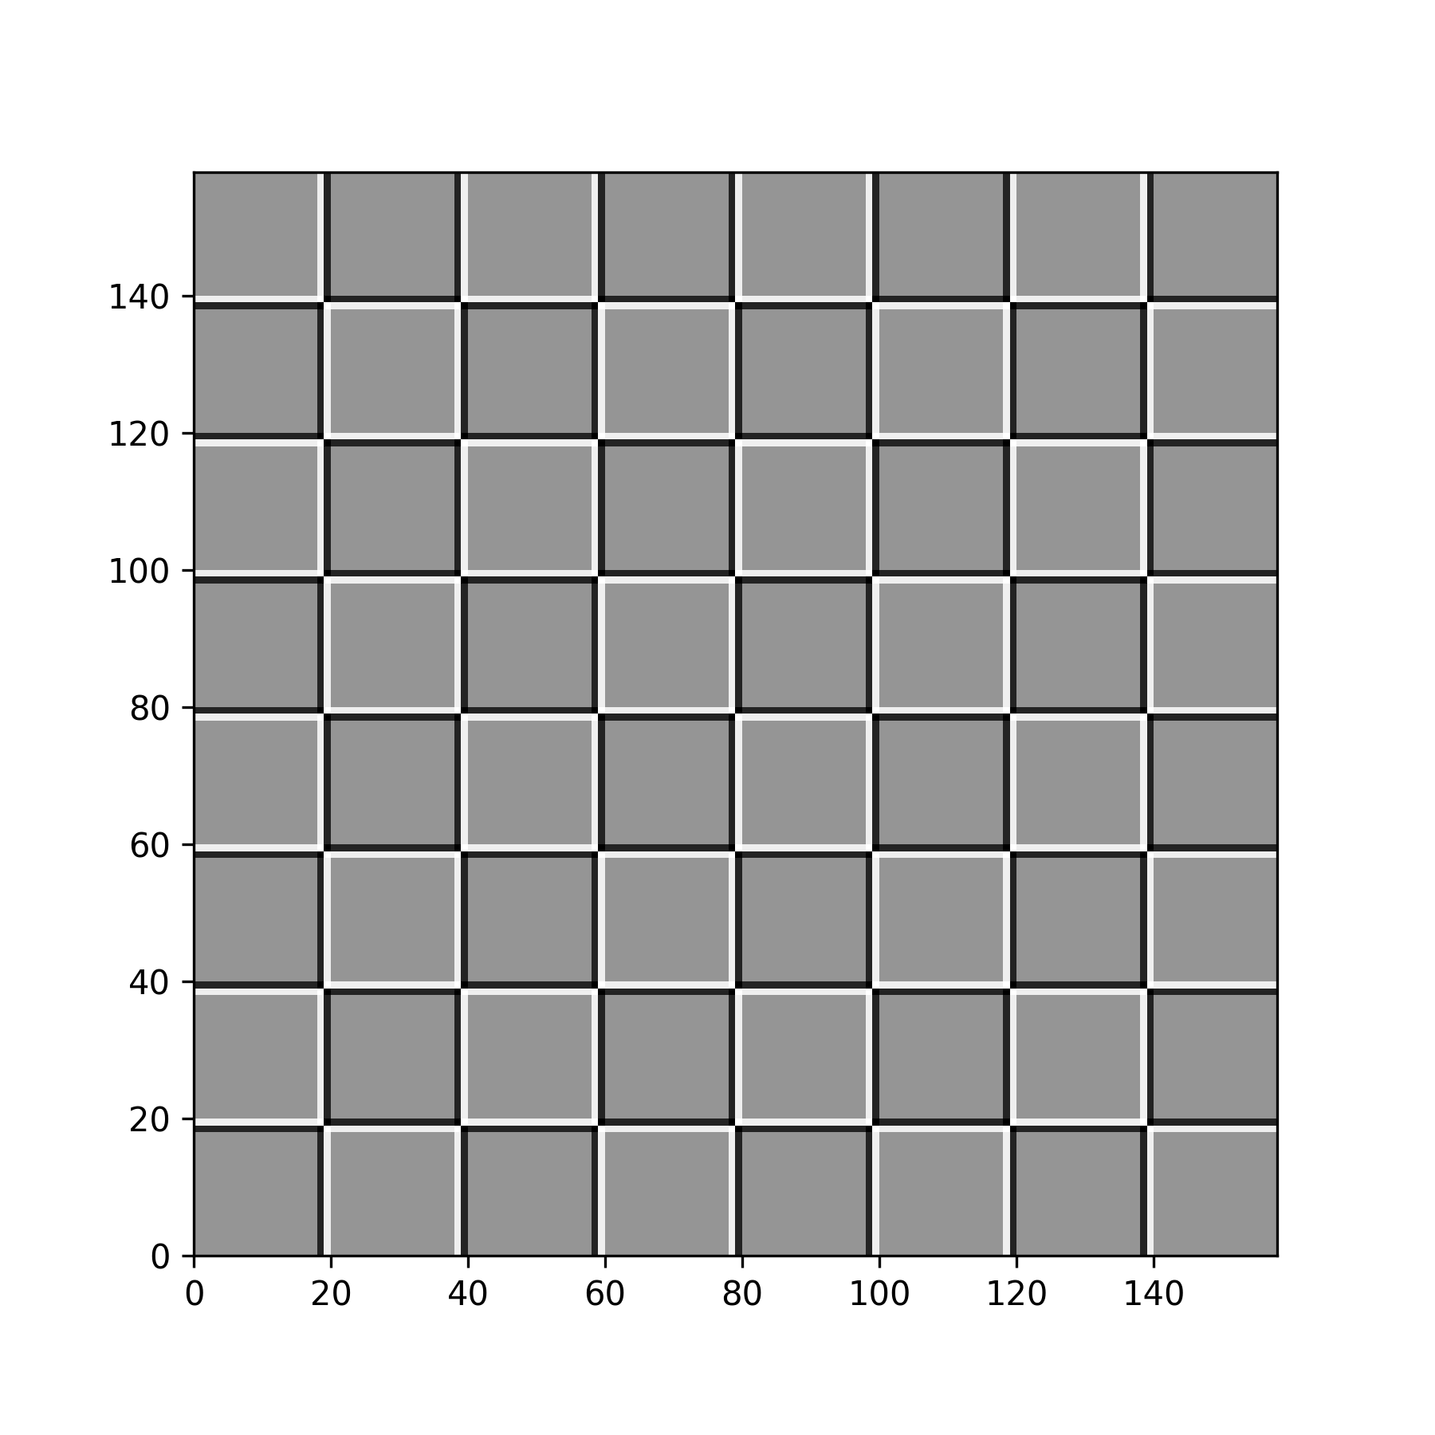

Figure 7-8. The result of performing a convolution between the kernel $I_{L}$ and the chessboard image.

And finally, we can apply the blurring kernel $I_{B}$

edge_blur = -1.0/9.0*np.matrix('1 1 1; 1 1 1; 1 1 1')

output_blur = conv_2d (chessboard, edge_blur)

In Figure 7-9 you can see two plots: on the left the blurred image and on the right theoriginal one. The images show only a small region of the original chessboard to make the blurring clearer.

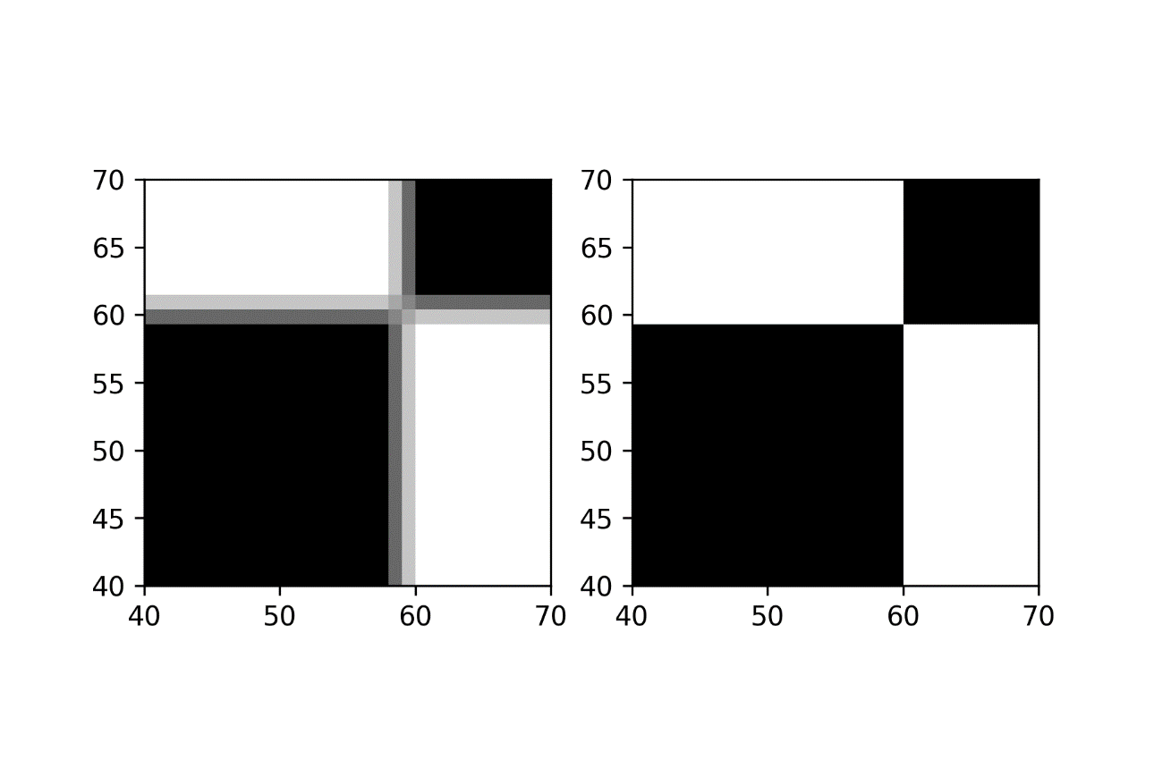

Figure 7-9. The effect of the blurring kernel $I_{B}$. On the left the blurred image and on the right the original one.

To finish this section let us try to understand better how the edges can be detected. Let us consider the following matrix with a sharp vertical transition, since the left part is full of 10 and the right part full of 0.

ex_mat = np.matrix('10 10 10 10 0 0 0 0; 10 10 10 10 0 0 0 0; 10 10 10 10 0 0 0 0; 10 10 10 10 0 0 0 0; 10 10 10 10 0 0 0 0; 10 10 10 10 0 0 0 0; 10 10 10 10 0 0 0 0; 10 10 10 10 0 0 0 0')

This looks like this

matrix([[10, 10, 10, 10, 0, 0, 0, 0],

[10, 10, 10, 10, 0, 0, 0, 0],

[10, 10, 10, 10, 0, 0, 0, 0],

[10, 10, 10, 10, 0, 0, 0, 0],

[10, 10, 10, 10, 0, 0, 0, 0],

[10, 10, 10, 10, 0, 0, 0, 0],

[10, 10, 10, 10, 0, 0, 0, 0],

[10, 10, 10, 10, 0, 0, 0, 0]])

and let us consider the kernel $I_{V}$. We can perform the convolution with the code

ex_out = conv_2d (ex_mat, edgev)

The result is

array([[ 0., 0., 30., 30., 0., 0.],

[ 0., 0., 30., 30., 0., 0.],

[ 0., 0., 30., 30., 0., 0.],

[ 0., 0., 30., 30., 0., 0.],

[ 0., 0., 30., 30., 0., 0.],

[ 0., 0., 30., 30., 0., 0.]])

in Figure 7-10 you can see the original matrix (on the left) and the output of the convolution on the right. The convolution with the kernel $I_{V}$ has clearly detected the sharp transition in the original matrix marking with a vertical black line where the transition from black to white happens. For example, consider $B_{11}=0$

$$\begin{matrix}B_{11}=\left(\begin{matrix}10 & 10 & 10 \\ 10 & 10 & 10 \\ 10 & 10 & 10\end{matrix}\right)*I_{V}=\left(\begin{matrix}10 & 10 & 10 \\ 10 & 10 & 10 \\ 10 & 10 & 10\end{matrix}\right)*\left(\begin{matrix}1 & 0 & -1 \\ 1 & 0 & -1 \\ 1 & 0 & -1\end{matrix}\right) \\ =10×1+10×0+10×-1+10×1+10×0+10×-1+10×1+10×0+10×-1=0\end{matrix}$$

Note that in the input matrix

$$\left(\begin{matrix}10 & 10 & 10 \\ 10 & 10 & 10 \\ 10 & 10 & 10\end{matrix}\right)$$

there is no transition, as all the values are the same. On the contrary if you consider $B_{13}$ you need to consider this region of the input matrix

$$\left(\begin{matrix}10 & 10 & 0 \\ 10 & 10 & 0 \\ 10 & 10 & 0\end{matrix}\right)$$

where there is a clear transition, since the rightest column is made of zeros, and the rest of 10. Now you get a different result

$$\begin{matrix}B_{11}=\left(\begin{matrix}10 & 10 & 0 \\ 10 & 10 & 0 \\ 10 & 10 & 0\end{matrix}\right)*I_{V}=\left(\begin{matrix}10 & 10 & 0 \\ 10 & 10 & 0 \\ 10 & 10 & 0\end{matrix}\right)*\left(\begin{matrix}1 & 0 & -1 \\ 1 & 0 & -1 \\ 1 & 0 & -1\end{matrix}\right) \\ =10×1+10×0+0×-1+10×1+10×0+0×-1+10×1+10×0+0×-1=30\end{matrix}$$

And this is exactly how, as soon as there is a big change in values along the horizontal direction the convolution will return a high value since the values multiplied by the column with 1 in the Kernel will be bigger. When on the opposite there is a transition from small to high values along the horizontal axis, the elements multiplied by -1 will give a result that is bigger in absolute value and therefore the final result will be negative and big in absolute value. This is the reason why this kernel can also detect if you pass from a light color to a darker color or vice versa. In fact, if you consider the opposite transition (from 0 to 10) in a hypothetical different matrix $A$ you would have

$$\begin{matrix}B_{11}=\left(\begin{matrix}0 & 10 & 10 \\ 0 & 10 & 10 \\ 0 & 10 & 10\end{matrix}\right)*I_{V}=\left(\begin{matrix}0 & 10 & 10 \\ 0 & 10 & 10 \\ 0 & 10 & 10\end{matrix}\right)*\left(\begin{matrix}1 & 0 & -1 \\ 1 & 0 & -1 \\ 1 & 0 & -1\end{matrix}\right) \\ =0×1+10×0+10×-1+0×1+10×0+10×-1+0×1+10×0+10×-1=-30\end{matrix}$$

since this time, we move from 0 to 10 along the horizontal direction.

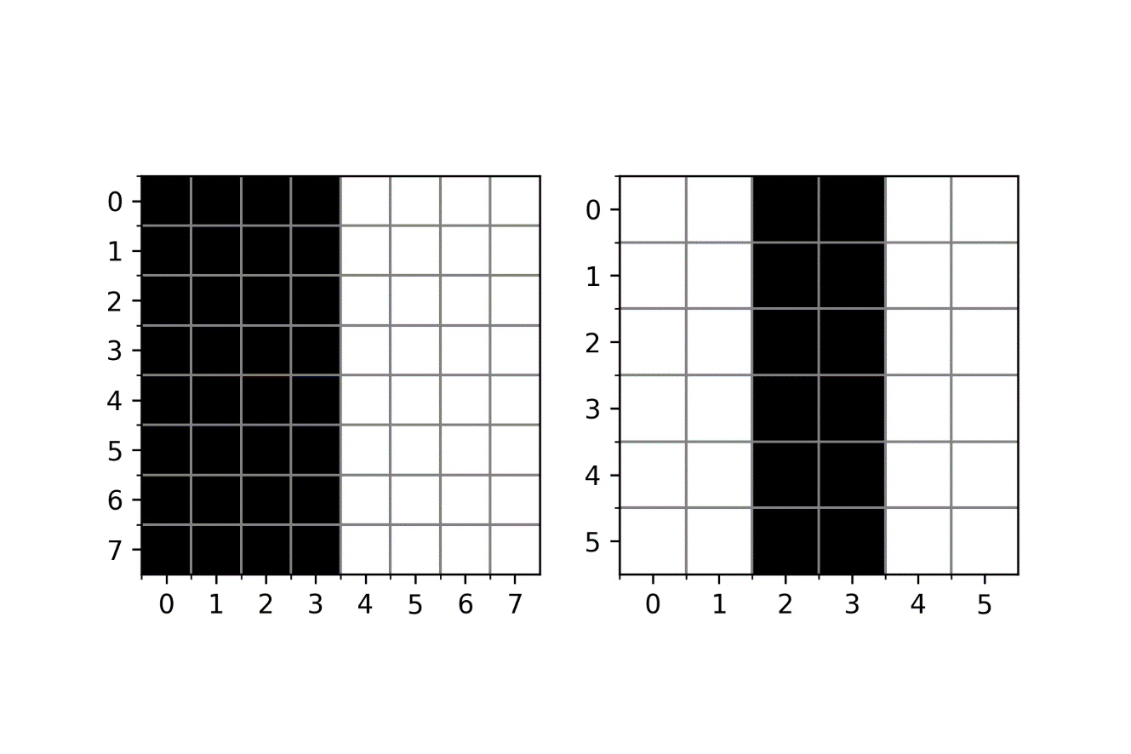

Figure 7-10. The result of the convolution of the matrix ex_mat with the kernel $I_{V}$ as described in the text.

Note how, as expected, the output matrix has dimensions $5×5$ since the original matrix has dimensions $7×7$ and the kernel is $3×3$.

## Pooling

Pooling is the second operation that is fundamental in CNNs. This operation is much easier to understand than convolution. To understand it lets again make a concrete example and let us consider what is called **max pooling**. Let us again consider our $4×4$ matrix we have discussed during our convolution discussion

$$A=\left(\begin{matrix}a_{1} & a_{2} & a_{3} & a_{4} \\ a_{5} & a_{6} & a_{7} & a_{8} \\ a_{9} & a_{10} & a_{11} & a_{12} \\ a_{13} & a_{14} & a_{15} & a_{16}\end{matrix}\right)$$

To perform max pooling, we need to define a region of size $n_{K}×n_{K}$, analogous to what we did for convolution. Let us consider $n_{K}=2$. What we need to do is to start on the top left corner of our matrix $A$ and select a $n_{K}×n_{K}$ region, in our case $2×2$ from $A$. Here we would select

$$\left(\begin{matrix}a_{1} & a_{2} \\ a_{5} & a_{6}\end{matrix}\right)$$

or the elements marked in bold face in the matrix $A$ here below

$$A=\left(\begin{matrix}a_{1} & a_{2} & a_{3} & a_{4} \\ a_{5} & a_{6} & a_{7} & a_{8} \\ a_{9} & a_{10} & a_{11} & a_{12} \\ a_{13} & a_{14} & a_{15} & a_{16}\end{matrix}\right)$$

From the elements selected, $a_{1}$, $a_{2}$, $a_{5}$ and $a_{6}$, the max pooling operation select the **maximum value** giving a result that we will indicate with $B_{1}$

$$B_{1}=\max_{i=1,2,5,6}{a_{i}}$$

Then we need to shift our $2×2$ window two columns, typically the same number of columns the selected region has, to the right and select the elements marked in bold

$$A=\left(\begin{matrix}a_{1} & a_{2} & a_{3} & a_{4} \\ a_{5} & a_{6} & a_{7} & a_{8} \\ a_{9} & a_{10} & a_{11} & a_{12} \\ a_{13} & a_{14} & a_{15} & a_{16}\end{matrix}\right)$$

or in other words the smaller matrix

$$\left(\begin{matrix}a_{3} & a_{4} \\ a_{7} & a_{8}\end{matrix}\right)$$

The max-pooling algorithm will then select the maximum of the values giving a result that we will indicate with $B_{2}$

$$B_{2}=\max_{i=3,4,7,8}{a_{i}}$$

At this point we cannot shift the $2×2$ region to the right anymore, so we shift it two rows down and start the process again from the left side of $A$, selecting the elements marked in bold below and getting the maximum and calling it $B_{3}$.

$$A=\left(\begin{matrix}a_{1} & a_{2} & a_{3} & a_{4} \\ a_{5} & a_{6} & a_{7} & a_{8} \\ a_{9} & a_{10} & a_{11} & a_{12} \\ a_{13} & a_{14} & a_{15} & a_{16}\end{matrix}\right)$$

The stride $s$ in this context has the same meaning we have already discussed in convolution. It is simply the number of rows or columns you move your region when selecting the elements. Finally, we select the last region $2×2$ in the bottom lower part of $A$, selecting the elements $a_{11}$, $a_{12}$, $a_{15}$ and $a_{16}$. We then get the maximum, and we then call it $B_{4}$. With the values we obtain in this process, in the example the four values $B_{1}$, $B_{2}$, $B_{3}$ and $B_{4}$, we will build an output tensor

$$B=\left(\begin{matrix}B_{1} & B_{2} \\ B_{3} & B_{4}\end{matrix}\right)$$

In the example we have $s=2$. Basically, this operation takes as input a matrix $A$, a stride $s$, and a kernel size $n_{K}$ (the dimension of the region we selected in the example before) and return a new matrix $B$ with dimensions given by the same formula we discussed for convolution

$$n_{B}=\left\lfloor \frac{n_{A}-n_{K}}{s}+1\right\rfloor$$

To reiterate the idea is to start from the top left of your matrix $A$, take a region of dimensions $n_{K}×n_{K}$, apply the max function to the selected elements, then shift the region of $s$ elements toward the right, select a new region again of dimensions $n_{K}×n_{K}$, apply the function to its values and so on. In Figure 15-11 you can see how you would select the elements from a matrix $A$ with a stride $s=2$.

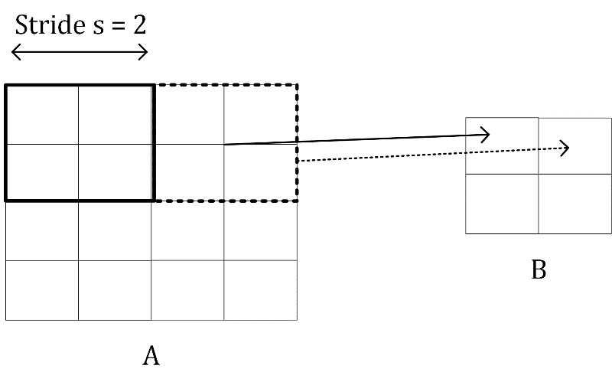

Figure 7-11. A visualization of pooling with stride $s=2$.

For example, applying max-pooling to the input $A$

$$A=\left(\begin{matrix}1 & 3 & 5 & 7 \\ 4 & 5 & 11 & 3 \\ 4 & 1 & 21 & 6 \\ 13 & 15 & 1 & 2\end{matrix}\right)$$

will get you the result (is very easy to verify it)

$$B=\left(\begin{matrix}4 & 11 \\ 15 & 21\end{matrix}\right)$$

since $4$ is the maximum of the values marked in bold

$$A=\left(\begin{matrix}1 & 3 & 5 & 7 \\ 4 & 5 & 11 & 3 \\ 4 & 1 & 21 & 6 \\ 13 & 15 & 1 & 2\end{matrix}\right)$$

$11$ is the maximum of the values marked in bold below

$$A=\left(\begin{matrix}1 & 3 & 5 & 7 \\ 4 & 5 & 11 & 3 \\ 4 & 1 & 21 & 6 \\ 13 & 15 & 1 & 2\end{matrix}\right)$$

and so on. Is worth mentioning another way of doing pooling, although not as widely used as max-pooling: **average pooling**. Instead of returning the maximum of the selected values it returns the **average**.

**Note** The most used pooling operation is "max pooling". "Average pooling" is not as widely used but can be found in specific network architectures.

## Padding

Something is worth mentioning, and that is the concept of padding. Sometime, when dealing with images, is not optimal to get a result from a convolution operation that has dimensions that are different from the original image. So sometimes you do what is called "padding". Basically, the idea is very simple: it consists in adding rows of pixels on the top and on the bottom and columns of pixels on the right and on the left of the final images filled with some values to make the resulting matrices the same size of the original one. Some strategies are filling the added pixels with zeros, with the values of the closest pixels and so on. For example, in our example our ex_out matrix with zero padding would be like this

array([[ 0., 0., 0., 0., 0., 0., 0., 0.],  
 [ 0., 0., 0., 30., 30., 0., 0., 0.],   
 [ 0., 0., 0., 30., 30., 0., 0., 0.],   
 [ 0., 0., 0., 30., 30., 0., 0., 0.],   
 [ 0., 0., 0., 30., 30., 0., 0., 0.],   
 [ 0., 0., 0., 30., 30., 0., 0., 0.],   
 [ 0., 0., 0., 30., 30., 0., 0., 0.],  
 [ 0., 0., 0., 0., 0., 0., 0., 0.]])

The use and reasons behind padding goes beyond the scope of this book but is important to know that this exists. Only as a reference, in case you use padding $p$ (the width of the rows and columns you use as padding) the final dimensions of the matrix $B$, in case of both convolution and pooling is given by

$$n_{B}=\left\lfloor \frac{n_{A}+2p-n_{K}}{s}+1\right\rfloor$$

**Note** When dealing with real images, you always have color images, coded in 3 channels: RGB. That means that you need to do convolution and pooling in three dimensions: width, height, and color channel. This will add a layer of complexity to the algorithms.

# Building blocks of a CNN

Basically, convolutions and pooling operations are used to build the layers used in CNNs. In CNNs typically you can find the following layers

* Convolutional layers
* Pooling layers
* Fully connected layers

Fully connected layers are exactly what we have already seen in all previous chapters: a layer where neurons are connected to all neurons of previous and subsequent layers. You know them already. But the first two require some additional explanation.

## Convolutional layers

A convolutional layer takes as input a tensor (can be 3-dimensional, due to the 3 color channels), for example an image of certain dimensions, applies a certain number of kernels, typically 10, 16, or even more, add a bias, apply ReLu activation functions (for example) to introduce non-linearity to the result of the convolution, and produce an output matrix $B$. If you remember the notation we used in the previous chapters, the result of the convolution will have the role of $W^{[l]}Z^{[l-1]}$ that we discussed in Chapter 3.

Now in the previous sections we have seen some examples of applying convolutions with just one kernel. How can you apply several kernels at the same time? Well, the answer is very simple. The final tensor (now we use the word tensor since it will not be a simple matrix anymore) $B$ will have now not $2$ dimensions but $3$. Let us indicate the number of kernels you want to apply with $n_{c}$ (the $c$ is used since sometimes people talk about channels). You simply apply each filter to the input independently and stack the results. So instead of a single matrix $B$ with dimensions $n_{B}×n_{B}$ you get a final tensor $\tilde{B}$ of dimensions $n_{B}×n_{B}×n_{c}$. That means that

$${\tilde{B}}_{i,j,1} ∀i,j∈[1,n_{B}]$$

will be the output of convolution of the input image with the first kernel,

$${\tilde{B}}_{i,j,2} ∀i,j∈[1,n_{B}]$$

will be the output of convolution with the second kernel and so on. The convolution layer is nothing else than something that transform the input into an output tensor. But what are the weights in this layer? The weights, or the parameter that the network learns during the training phase, are the elements of the kernel themselves. We have discussed that we have $n_{c}$ kernels, each of $n_{K}×n_{K}$ dimensions. That means that we have $n_{K}^{2}n_{c}$ parameter in a convolutional layer.

**Note** The number of parameters that you have in a convolutional layer, $n_{K}^{2}n_{c}$, is independent from the input image size. This fact helps in reducing overfitting, especially when dealing with big size input images.

Sometime this layer is indicated with the word **CONV** and then a number. In our case we could indicate this layer with CONV1. In Figure 15-12 you can see a representation of a convolutional layer. The input image gets transformed by applying convolution with $n_{c}$ kernels in a tensor of dimensions $n_{A}×n_{A}×n_{c}$.

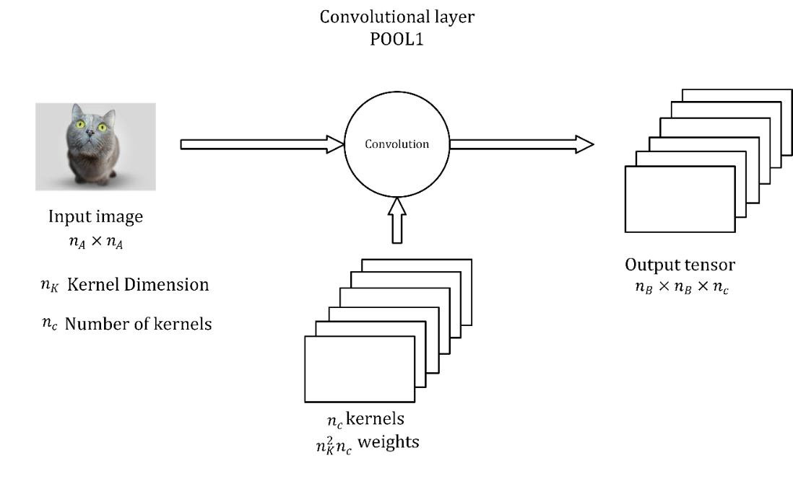

Figure 15-12. A representation of a convolutional layer[1].

Of course, a convolutional layer must not necessarily be placed immediately after the inputs. A convolutional layer may get as input the output of any other layer of course. Keep in mind that usually your input image will have dimensions $n_{A}×n_{A}×3$, since an image in color has 3 channels: Red, Green and Blue. A complete analysis of the tensors involved in a CNN when considering color images will go beyond the scope of this book. Very often in diagrams the layer is simply indicated as a cube or a square.

## Pooling layers

A pooling layer is usually indicated with **POOL** and a number: for example, POOL1. It takes as input a tensor and gives as output another tensor after applying pooling to the input.

**Note** A pooling layer has no parameter to learn, but it introduces additional hyperparameters: $n_{K}$ and stride $s$. Typically, in pooling layers you do not use any padding, since one of the reasons to use pooling is often to reduce the dimensionality of the tensors.

## Stacking layers together

In CNNs you usually stack convolutional and pooling layers together. One after the other. In Figure 15-13 you can see a convolutional and a pooling layer stack. A convolutional is always followed by a pooling layer. Sometimes the two together are called a layer. The reason is that a pooling layer has no learnable weights and therefore it is simply seen as a simple operation that is associated with the convolutional layer. So be aware when you read papers or blogs and check what they intend.

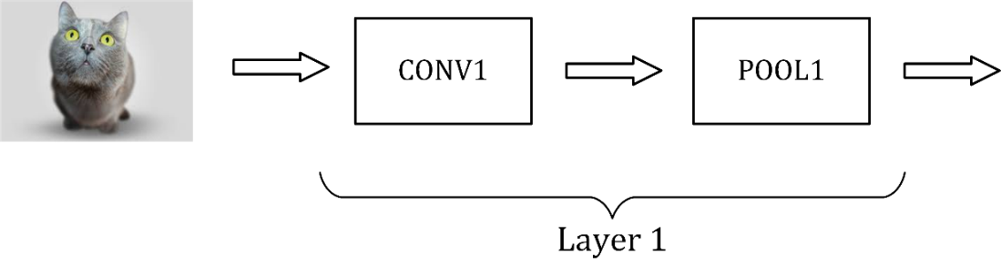

Figure 15-13. A representation of how to stack convolutional and pooling layers.

To conclude this part on CNNs in Figure 15-14 you can see an example of a CNN. In Figure 15-14 you can see an example like the very famous LeNet-5 network [1]. You have the inputs, then two times convolution-pooling layer, then 3 fully connected layers and then an output layers, where you may have your softmax function in case, for example, you perform multiclass classification. I put some indicative numbers in the Figure to give you an idea of the size of the different layers.

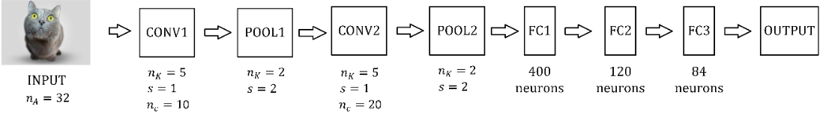

Figure 15-14. A representation of a CNN similar to the famous LeNet-5 network.

# An example of a CNN

Let us try to build one such a network to give you a feeling of how the process would work and how the code looks like. We will not do any hyperparameter tuning or optimization to keep the section understandable. We will build the following architecture with the following layers in this order:

* **Convolution layer 1 (CONV1)**: 6 Filters $5×5$, stride $s=1$
* We then apply **ReLU** to the output of the previous layer
* **Max pooling layer 1 (POOL1)** with a window $2×2$, stride $s=2$
* **Convolution layer 2 (CONV2)**: 16 Filters $5×5$, stride $s=1$
* We then apply **ReLU** to the output of the previous layer
* **Max pooling layer 2 (POOL2)** with a window $2×2$, stride $s=2$
* **Fully Connected Layer** with $128$ neurons with activation function ReLU
* **Fully Connected Layer** with 10 neurons for classification of the Zalando dataset
* **Softmax** output neuron

We will import the Zalando dataset as we did in Chapter 13:

((trainX, trainY), (testX, testY)) = fashion_mnist.load_data()

Check there if you do not remember the dataset’s details. Then let us prepare the data (reshaping the samples and one-hot encoding the labels)

labels_train = np.zeros((60000, 10))

labels_train[np.arange(60000), trainY] = 1

data_train = trainX.reshape(60000, 28, 28, 1)

and

labels_test = np.zeros((10000, 10))

labels_test[np.arange(10000), testY] = 1

data_test = testX.reshape(10000, 28, 28, 1)

Note that in this case, differently than in Chapter 13, we will use as network’s inputs tensors of dimensions (number_of_images, image_height, image_width, color_channels). Since the Zalando dataset is made of gray values images, the color_channels will be equal to 1. In Chapter 13 each observation was in a row (since feed-forward neural networks takes as input flattened tensors). If you check the dimensions with the code

print('Dimensions of the training dataset: ', data_train.shape)

print('Dimensions of the test dataset: ', data_test.shape)

print('Dimensions of the training labels: ', labels_train.shape)

print('Dimensions of the test labels: ', labels_test.shape)

you will get the results

Dimensions of the training dataset: (60000, 28, 28, 1)

Dimensions of the test dataset: (10000, 28, 28, 1)

Dimensions of the training labels: (60000, 10)

Dimensions of the test labels: (10000, 10)

As in Chapter 13 we need to normalize the data

data_train_norm = np.array(data_train/255.0)

data_test_norm = np.array(data_test/255.0)

We can now start to build our network. With Keras, creating and training a CNN model is straightforward; the following function defines the network’s architecture

def build_model():

# create model

model = models.Sequential()

model.add(layers.Conv2D(6, (5, 5), strides = (1, 1),

activation = 'relu', input_shape = (28, 28, 1)))

model.add(layers.MaxPooling2D(pool_size = (2, 2),

strides = (2, 2)))

model.add(layers.Conv2D(16, (5, 5), strides = (1, 1),

activation = 'relu'))

model.add(layers.MaxPooling2D(pool_size = (2, 2),

strides = (2, 2)))

model.add(layers.Flatten())

model.add(layers.Dense(128, activation = 'relu'))

model.add(layers.Dense(10, activation = 'softmax'))

# compile model

model.compile(loss = 'categorical_crossentropy',

optimizer = 'adam',

metrics = ['categorical_accuracy'])

return model

Remember that the convolutional layer will require the 2-dimensional image, and not a flattened list of gray values of the pixel as we have done in Chapter 13, where our input was a vector with 784 ( $28×28)$ elements.

**Note** One of the biggest advantages of CNNs is that they use the 2-dimensional information contained in the input image, this is the reason why the input of convolutional layers are 2-dimensional images, and not a flattened vector.

When building CNNs in Keras, a single line of code (and a Keras method) will correspond to a different layer. The above-defined build_model function creates a CNN stacking Conv2D (that builds a convolutional layer) and MaxPooling2D (that builds a max pooling layer) layers. The stride is a tuple since it gives the stride in different dimensions (for rows and columns). In our examples we have gray images, but we could also have RGB for example, therefore having more dimensions: the 3 color channels.

Let us display the architecture of our model so far, by model.summary():

Model: "sequential"

______________________________________________________________

Layer (type) Output Shape Param #

==============================================================

conv2d (Conv2D) (None, 24, 24, 6) 156

______________________________________________________________

max_pooling2d (MaxPooling2D) (None, 12, 12, 6) 0

______________________________________________________________

conv2d_1 (Conv2D) (None, 8, 8, 16) 2416

______________________________________________________________

max_pooling2d_1 (MaxPooling2 (None, 4, 4, 16) 0

______________________________________________________________

flatten (Flatten) (None, 256) 0

______________________________________________________________

dense (Dense) (None, 128) 32896

______________________________________________________________

dense_1 (Dense) (None, 10) 1290

==============================================================

Total params: 36,758

Trainable params: 36,758

Non-trainable params: 0

______________________________________________________________

From above, you can note that the output of every convolutional and pooling layer is a 3D tensor of shape (height, width, number_of_filters). The first dimension (i.e., the number of batches, is set to None since the network does not know it yet and thus it can be applied to every set of samples, of any length). The width and height dimensions decrease as you go deeper in the network. The number of output channels for each Conv2D layer is controlled by the first function argument. Typically, as the width and height decrease, you can afford (computationally) to add more output filters in each Conv2D layer.

To complete the model, we added two Dense layers. They take vectors as input (which are 1D), while the current output is a 3D tensor. This is the reason why you first need to flatten the 3D output to 1D, then add one or more Dense layers on top.

Now is time to train and test our network. We will use mini-batch gradient descent with a batch size of 100 and we will train our network for just 10 epochs.

model.fit(data_train_norm, labels_train, validation_data = (data_test_norm, labels_test), epochs = 10, batch_size = 100, verbose = 1)

If you run this code (it took roughly 4 minutes on a medium performance laptop), it will start, after just one epoch, with a training accuracy of 76.3%, and after 10 epochs it will reach a training accuracy of 91% (88% on the dev set). Remember that with the network we developed in Chapter 13 with 15 neurons in one layer we reached about 90% with mini-batch gradient descent (50 as batch size), after 100 epochs. We have trained our network here only for 10 epochs. You can get much higher accuracy if you train longer. Additionally, note we have not done any hyperparameter tuning so this would get you much better results if you spent time tuning the parameters.

As you may have noticed, every time you introduce a convolutional layer you will introduce new hyperparameters for each layer:

* Kernel size
* Stride
* Padding

Those will need to be tuned to get optimal results. Typically, researchers tend to use existing architectures for specific tasks that have been already optimized by other practitioners and are well documented in papers.

You should now have a basic understanding of how CNN networks work, and on what principles they work on. Convolutional neural networks are used extensively in multiple forms for various tasks from classification (as we have seen here) to object localization, object segmentation, instance segmentation and much more. In this chapter we have just scratched the surface. But now you should understand the building blocks of CNNs and should be able to understand how much more complex architecture are built and structured.

# Exercises

EXERCISE 1 (Convolution)

Try to apply the different convolution operators like the ones we saw together in this Chapter, but to different images, like the handwritten digits of the MNIST database (<http://yann.lecun.com/exdb/mnist/>). To download the dataset from TensorFlow use the following lines of code:

from tensorflow import keras

(x_train, y_train), (x_test, y_test) = keras.datasets.mnist.load_data()

Difficulty: easy.

EXERCISE 2 (CNN) (LEVEL EASY)

Try to build a multiclass classification model like the one we saw together in this notebook, but with a different dataset, the MNIST database of handwritten digits.

exercise 3 (CNN)(LEVEL MEDIUM)

Try to change the network's parameters to see if you can get a higher accuracy. Change kernel size, stride, and padding.

# References

[1] <https://goo.gl/hM1kAL>, last accessed 19.07.2021

[2] <https://goo.gl/FodLp5>, last accessed 21.07.2021

[3] <https://goo.gl/8Ja3n2>, last accessed 21.07.2021

1. Cat image source: <https://www.shutterstock.com/>